Course Name | ITD 2313 – Script Programming
Instructor | Rene Hurst
Student Name | Pete Fuentez
Due date | Sep 29 by 11:59 pm
Grade | Put grade earned here
Grading Comments | Put instructor comments here

Week 8 - Textbook Exercises
Chapter 6
Functions Eliminate Redundancy
Page 147
There is an example at the bottom of the page with a function and it being used a few times. The code example block does spill over to the top of the next page. 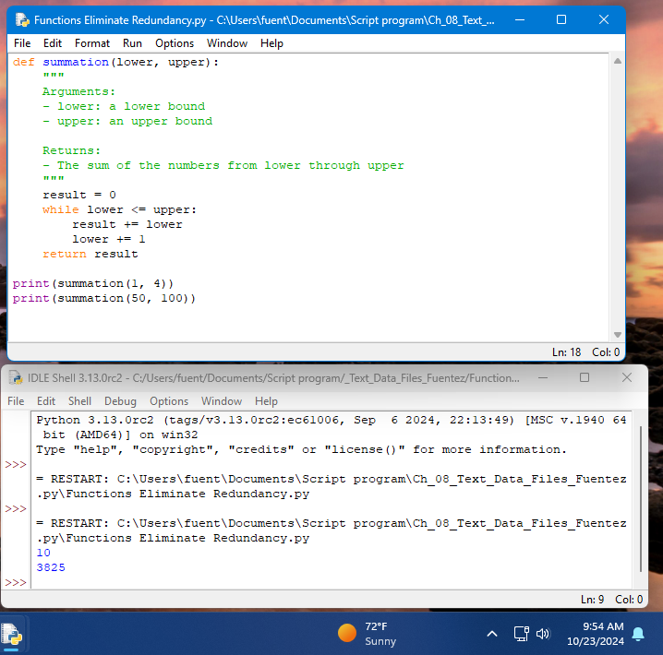

Managing a Program's Namespace
Module Variables, Parameters, and Temporary Variables
Page 156
About 2/3 ways down, is the code example block. 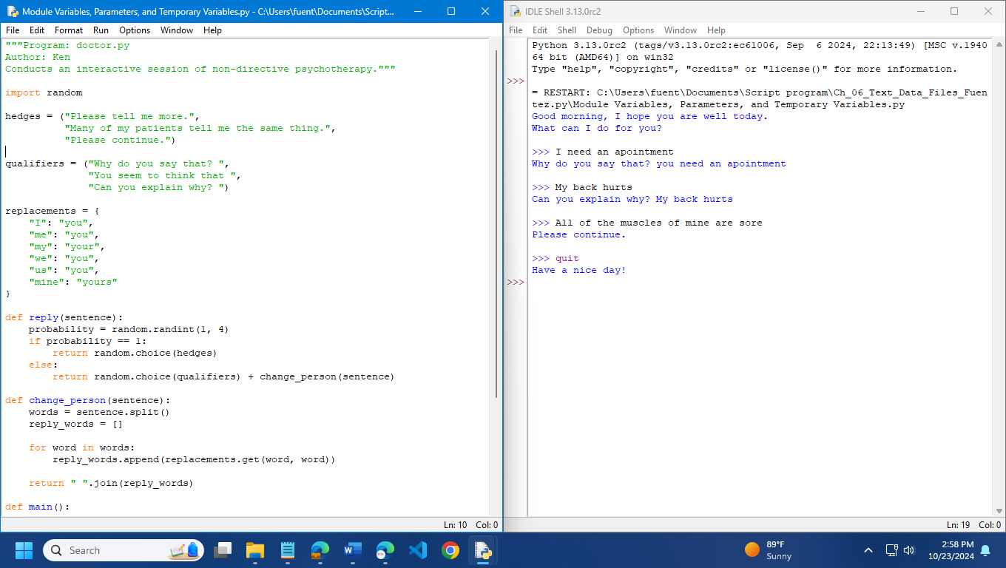

Scope
Page 157
About 3/4 of the ways down the page is a very small code example block showing the effects of scope. 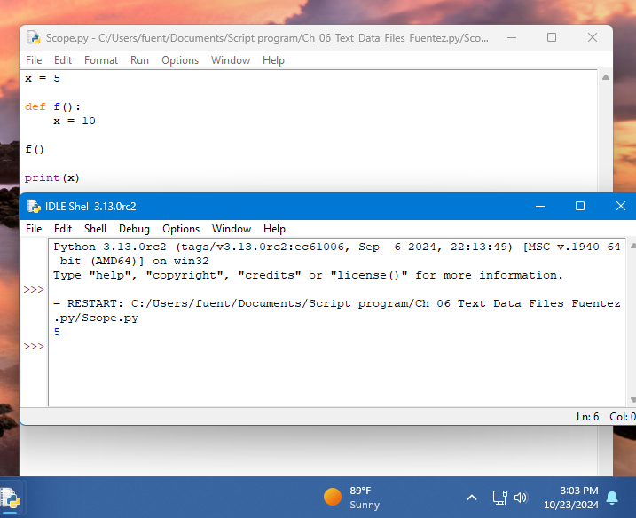

Using Keywords for default and Optional Arguments
Page 158
An important note here is that the function that is used in this first code example block is actually on page 158 and will need to be entered. 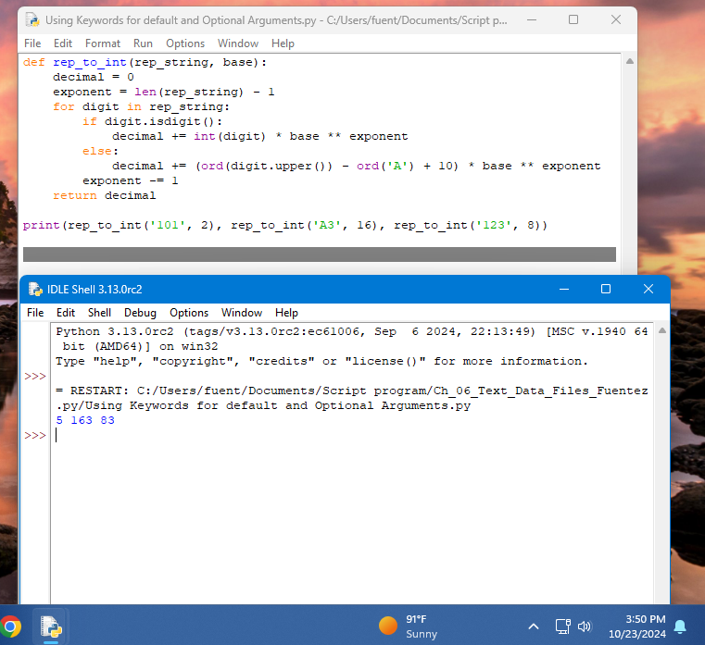

Start this instruction set by entering that code on page 158 and then doing this first code example block on the top 1/4 of the page 159 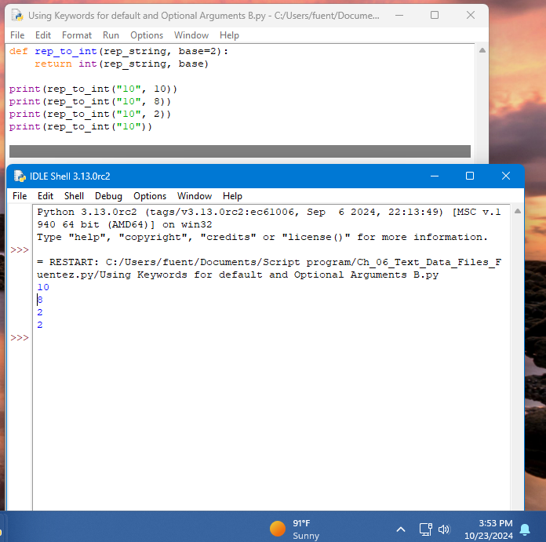.
The second code example block is about 2/3 the way down on the page. This also has a small definition of a function at the beginning of the code example block. 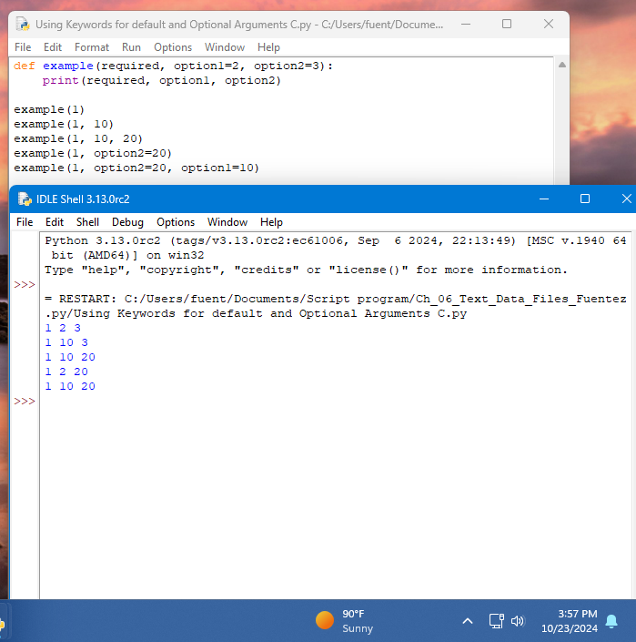

Chapter 7
Design with Recursive Functions
Defining a Recursive Function
Page 166
About 1/4 ways down, the first code example block on this page is not a recursive function but should be done. You will need to add the code to execute the function though. 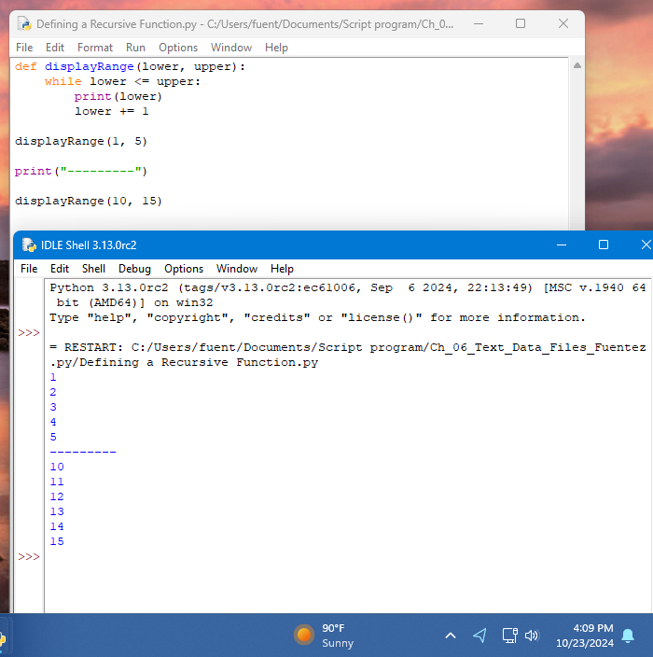
About 1/2 ways down, the code example block, is a recursive function. You will again need to add the code to execute the function. 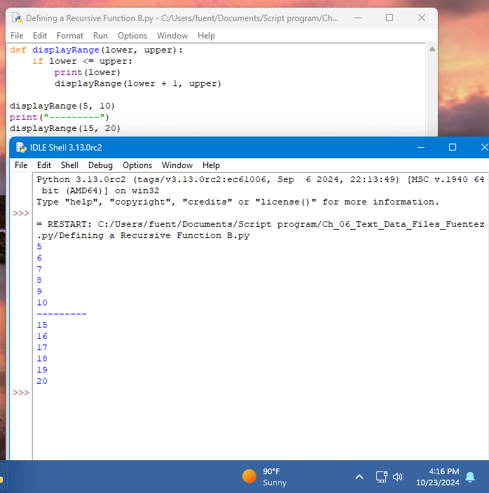
At the bottom of the page is another recursive code example block. You will need to add in the execute code on this one also. 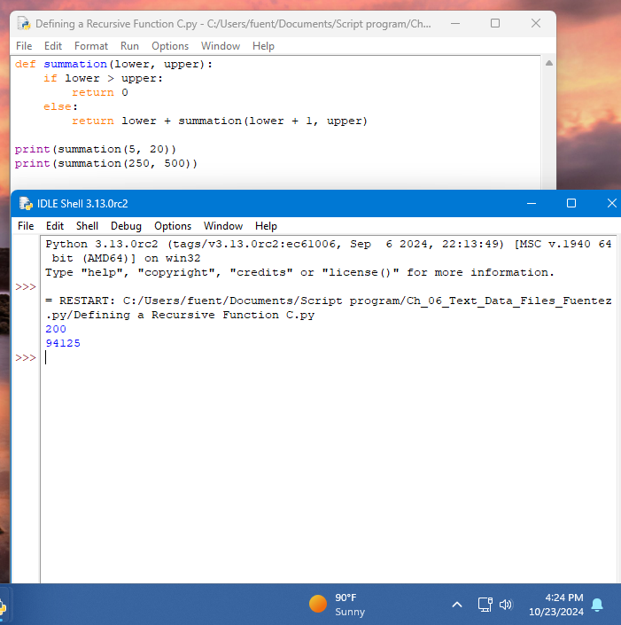
The code example block on the bottom of the page spills onto the next page. The screen shots for that one will go on that page. 00000000000000000000000000000000000000000000000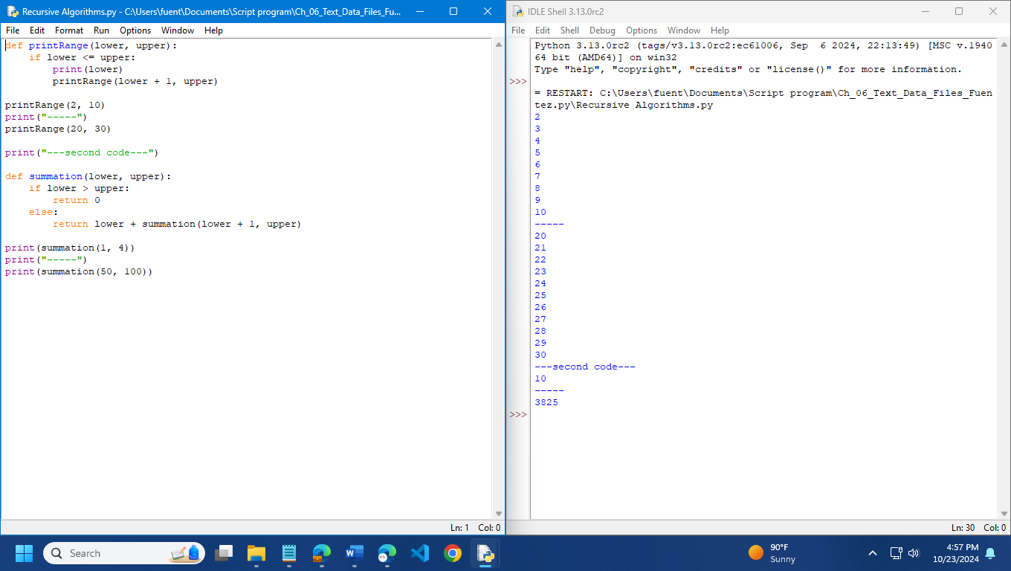

Tracing a Recursive Function
Page 167
At the bottom of the page is another recursive function. You will need to add in the code to execute that function also. 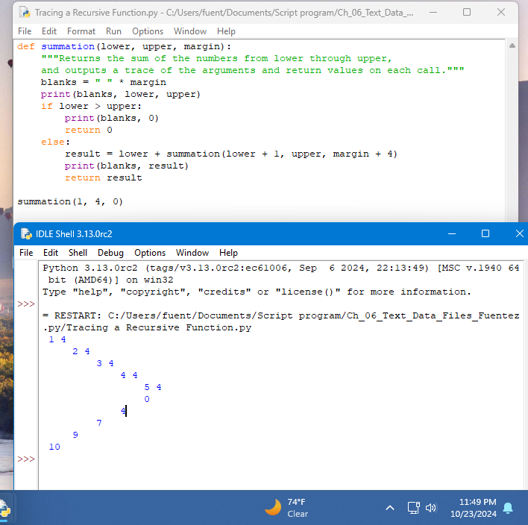

Recursive Sentence Structure
Page 168-169
The code for some items for this is not there. This is more a theoretical example. So do not try and make screenshots on it.
Infinite Recursion
Page 170
Yes, there is a code example block of infinite recursion. It will cause an error. You are to do the code example block and capture the resulting error. 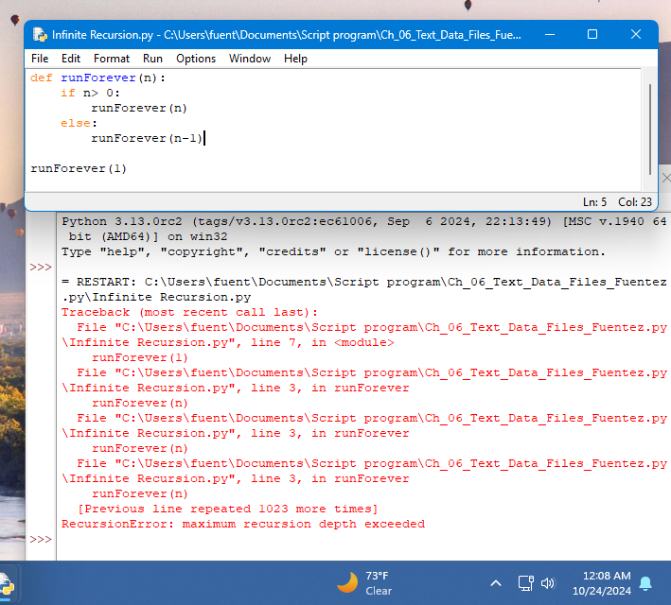
Higher-Order Functions
Functions as First-Class Data Objects
Page 179
The code example block is at the bottom of the page and spills over to the top 1/3 of the page. 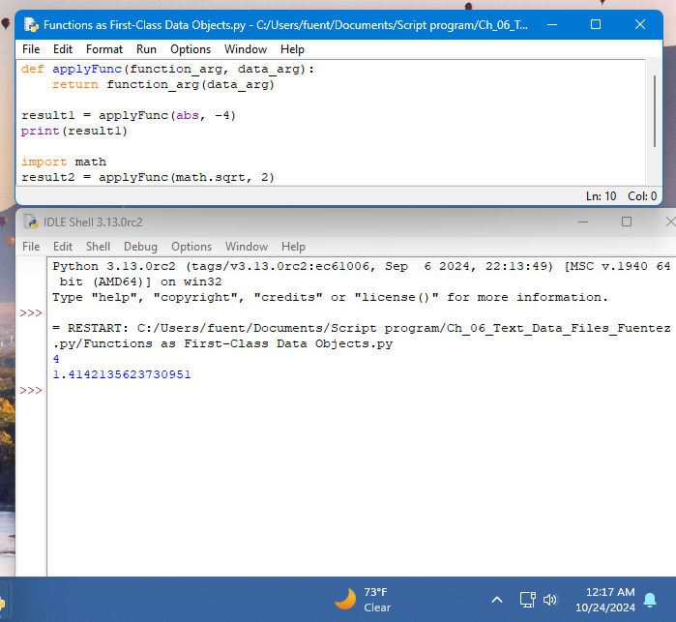

Mapping
Page 180
About 1/2 way down the page, the code example block can be found
The last code example block at the bottom of the page and is making some changes to the doctor program that is part of the chapter download. It continues on the next page. You should review and try this but do not need to take a screen shot of the work for this one.

Filtering
Page 181
Just a little below the 1/2 point on the page is the code example block for this page that needs a screen shot captured. 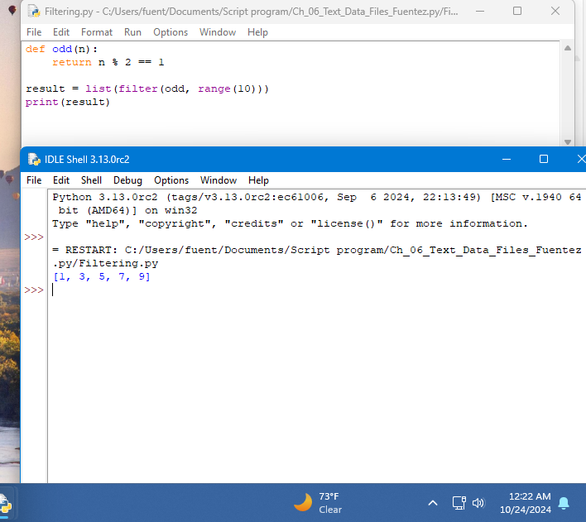

Reducing
Page 181- 182
The first code example block is at the bottom of the page. 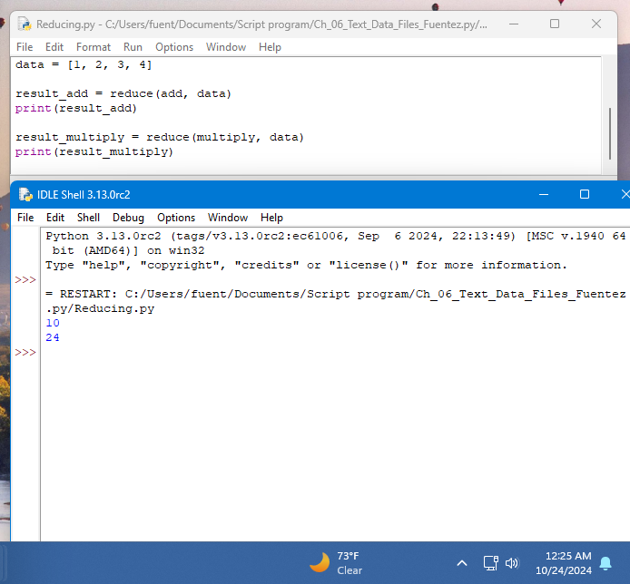
The second code example block is about 1/2 the way down on the page (182) and deals with lambda. 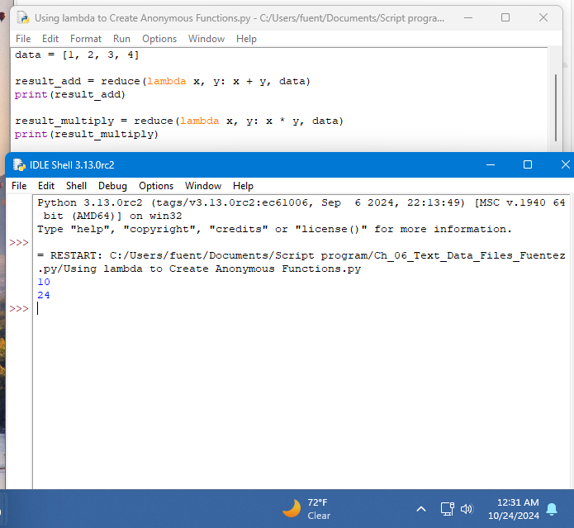
The last code example block for this page is just after the code for the lambda. It brings several of the concepts together into a single function. It does not have a use of it in the example so you will need to write your own use of the function to show it works. 